STUDENT VERSION

Modeling Population Growth of a Dairy Farm

Robert Krueger
Department of Mathematics
Concordia University, St. Paul
1282 Concordia Avenue
St. Paul, MN 55104
rkrueger@csp.edu

Abstract: A simple first order population growth model is presented. The challenge is to produce a final differential equation which is the result of the difference or ratio of birth and death rates. This ratio is not immediately intuitive.

Keywords: Differential Equations, population growth, separable, first order

Tags: Differential Equations, population growth, separable, first order, dairy, farm, Holstein, cow

Please do not read the back of this page until instructed to do so. Enjoy!

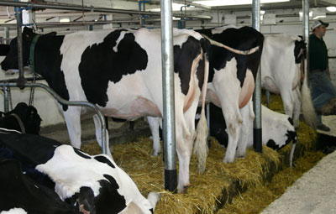
STATEMENT

Tim, the Midwestern dairy farmer, has a problem. He doesn’t make any money selling milk. Unfortunately, he barely breaks even after expenses with the average market value of 100 pounds (just under 12 gallons) of milk selling for around $15 [Tebbe2019]. It is hard to make a living under those dire circumstances. To combat this, he has developed an exceptional breed of Holstein cattle. These cattle are sought after by large dairy farms who want superior stock without the work of raising the calves until they are “fresh” (recently given birth to a calf and ready to milk). About 90% of the 9 million dairy cows in the United States are Holsteins. [Holstein2019]
Figure 1: Holstein Cows in a Tie-Stall Barn [Holstein2019]

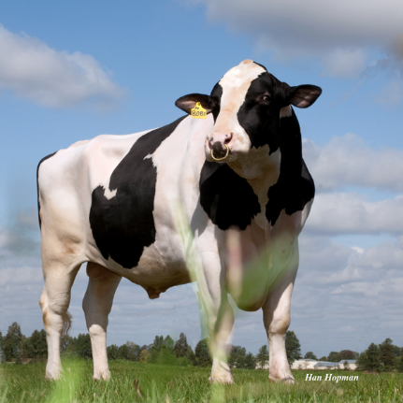
Tim currently has 100 cows (female cattle) evenly distributed in age and enough bulls (male cattle) to aid in calf production. Based on experience and a little research, he has enough land, shelter, and equipment to hold up to a maximum of 600 cows plus the bulls necessary for the operation. All other cattle can be sold for profit. Our goal is to model the growth of Tim’s cow population using differential equations.

1) What other information do you think is necessary for us to begin to model the herd? Write down a few thoughts.

DO NOT TURN OVER THE SHEET UNTIL INSTRUCTED!
Figure 2: Holstein Bull [Hopman2013]

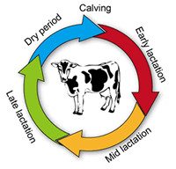
Here is some pertinent information:
- A cow is ready to breed at 15 months.
- The gestation period (pregnancy) is 9 months.
- A cow is fertile about 3 months after giving birth. The yearly lactation cycle is given in Figure 3.
- Assume the lifespan of a cow is 6 years before they are sold for beef.

2) Draw a lifespan timeline for a typical cow.

Figure 3: Lactation Cycle [FAO2014]

3) Recall we wish to model the size of the cow population (female only) on Tim’s farm. How is the size of the population changing per year? Write out as much as you can in words.

4) Write a differential equation for the change in the herd per year: $\frac{dH}{dt}=$_______________

5) What is the initial condition?

6) Solve the first order initial value problem you have created for $H(t)$.

7) When will Tim reach the maximum number of cows his farm can hold?

